Name ____________________
Hour ____ Date ____________

Elements  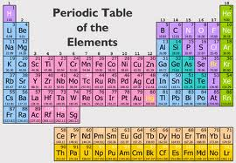 | Compounds | 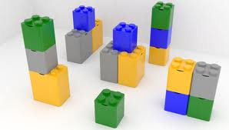  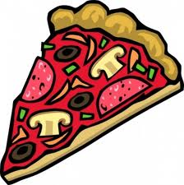  Mixtures
- Pure substance  - smallest piece is an atom  - Can not be broken down  - Have characteristic properties (both chemical and physical) | - Pure substance  - smallest piece is a molecule  - Can be broken down into elements or simpler compounds.  - Made from a chemical combination of elements (set ratio)  - Have characteristic properties which are different than the elements which they are made from.  - Are combined and broken down by chemical changes. | - Not a pure substance  - Can be broken down by physical means  - Made from elements and/or compounds (any amount)  - Retain the properties of the substances which make up the mixture

