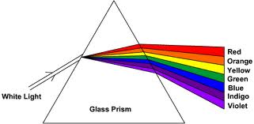
Name ________________ Hr. __

Bill Nye: Light and Color
- White light is a mixture of all of the ________________.
- Without different colors of light, we couldn’t see different _________ of things.
- All the colors of the rainbow are called the full ____________ of color.
- List the colors of the rainbow in order.

- Each color is its own ________________.
- Red + Blue = ______________.
- Yellow + Red = ______________.
- Yellow + Blue = _______________.
- All of the colors mixed together make _____________.
- Why is a green apple green?

- We don’t see _____________, we see __________ bouncing off things.
- The colors that aren’t reflected are ____________ and change to ___________.
- Mixing the colors of light gives you __________ light.
- ____________are beams of very intense light.
- The smoke at dance parties is so that light has something to ___________.
- The color of an object is __________ of the light it ___________.
- Black colors absorb all colors and convert them to _____________.
- White helps you stay ___________, because it reflects ___ __________.
- __________, ___________, and __________ are primary colors of light.
- __________light is long, slow waves. ___________ light is short, fast waves.
- Why is water blue?

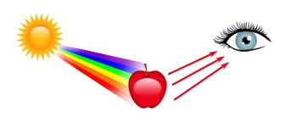
- _____________ light is scattered a lot more than __________ light in the sky, so we see more of it and it makes the sky look blue.
- White objects ____________ all colors.
- Black objects _____________ all colors.

