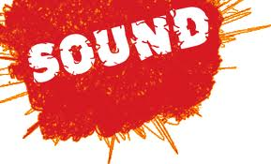
Name _________________ Hr ___
Bill Nye:
- Sound is __________ vibrations of __________.
- An oscilloscope is a device that lets us see __________ in the air.
- Sound travels 18X faster through __________ than __________.
- A slinky is perfect to show us how __________waves travel through __________.
- What happens when the wave his the wooden barrier?
_________________________________________________________
- What is it called when a sound wave hits something and bounces back?
_________________________________________________________
- Sound waves often reflect off __________ surfaces.
- __________ waves enter the ear canal.
- The eardrum __________, which moves tiny __________ in the middle ear. The bones pound on the seashell shaped inner ear.
- The waves hit tiny hairs, which send __________ to the brain to process the sound.
- Higher frequency (more waves per second) means __________ pitch.
- Lower frequency (less waves per second) means __________ pitch.
- Things tend to vibrate at their natural __________.
- __________ are specialized structures designed to receive sound.
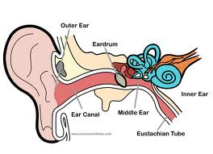

- Draw a Transverse wave.
_ _ _ _ _ _ _ _ _ _ _ _ _ _ _ _ _ _ _ _ _ _ _ _ _ _ _ _ _ _ _ _ _ _ _ _ _ _ _

- Label the above wave with the rest position, amplitude, crest, trough, and wavelength.

- Draw a wave with a higher frequency than the wave you drew on #15.
_ _ _ _ _ _ _ _ _ _ _ _ _ _ _ _ _ _ _ _ _ _ _ _ _ _ _ _ _ _ _ _ _ _ _ _ _ _ _

- Draw a wave with a lower frequency than the wave you drew on #15.
_ _ _ _ _ _ _ _ _ _ _ _ _ _ _ _ _ _ _ _ _ _ _ _ _ _ _ _ _ _ _ _ _ _ _ _ _ _ _

