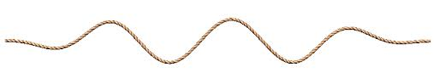
Name ________________ Hr___
What are waves?
Pp 528-536
Directions: Read each “chunk” in your textbook. In the provided space write a brief summary, draw an illustration, or give a real world example (your teacher will tell you which one(s).
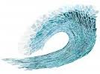
- What are Waves?

  - A Source of Energy

  - Energy Transfer

  - How Waves Transfer Energy

- Mechanical Waves

  - Transverse Waves
  - Longitudinal Waves

  - Vibrations and Mechanical Waves

- Types of Mechanical Waves

  - Sound Waves

  - Water Waves

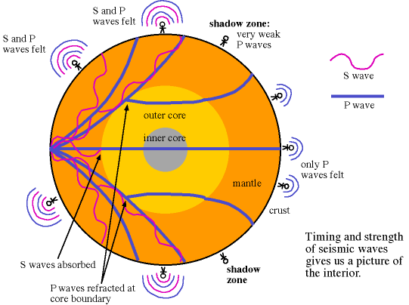
  - Seismic

- Electromagnetic Waves

  - Types of Electromagnetic Waves

  - Electromagnetic Waves and Objects

  - Electromagnetic Waves from the Sun
