Name _________________ hr. __
Directions: Complete the graphic organizer below with definitions in your own words and examples. Use your textbook as a reference.
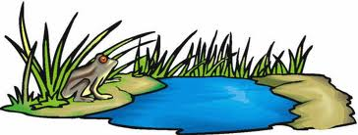
Ecosystem

Abiotic Factors Biotic Factors

Producers Consumers Decomposers

Herbivores Carnivores Omnivores Scavengers

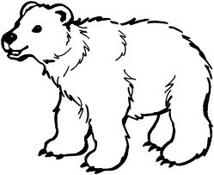
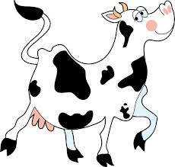
Directions: Complete the graphic organizer below using vocabulary terms and examples from the word bank. Use your textbook as a reference.

Eats Producers Eats Consumers

Word Bank
Herbivore Lion Human Only eats consumers
Omnivore Rabbit Bullfrog Only eats producers
Carnivore Bear Cow Eats producers and consumers
Horse Shark Pig Is a consumer

