Name _________________ Growl

**Collecting and Analyzing Data**

**Problem:** Are there more ambidextrous people in Growl class than average?

**Gather Information:** What does ambidextrous mean? Where can I find this info?

______________________________________________________________

______________________________________________________________

**Write a Hypothesis:** If_______________________________________, then _____________________________________________________________.

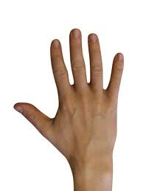

**Design and Perform the experiment:**

1. 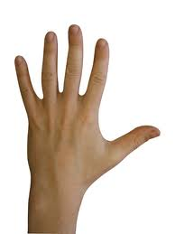Using a timer, write the first letter of your last name in each box of the grid paper with your right hand for 20 seconds.
2. Using a timer, write the first letter of your last name in each box of the grid paper with your left hand for 20 seconds.
3. Count and record the number of letters you were able to write in the boxes and record your data in the table below.

**Record and Analyze the Data**

|  |  |  |
| --- | --- | --- |
|  | Number of letters with my **Right** hand | Number of letters with my **Left** hand |
| Me |  |  |

1. Now, share the data with the class by creating a classroom data table. Every student must make their own.

|  |  |  |
| --- | --- | --- |
| Name of Student | Number of Letters  (Right Hand) | Number of Letters  (Left Hand) |
| 1. |  |  |
| 2. |  |  |
| 3. |  |  |
| 4. |  |  |
| 5. |  |  |
| 6. |  |  |
| 7. |  |  |
| 8. |  |  |
| 9. |  |  |
| 10. |  |  |
| 11. |  |  |
| 12. |  |  |
| 13. |  |  |
| 14. |  |  |
| 15. |  |  |
| 16. |  |  |
| 17. |  |  |
| 18. |  |  |
| 19. |  |  |
| 20. |  |  |
| 21. |  |  |
| 22. |  |  |
| 23. |  |  |
| 24. |  |  |
| 25. |  |  |

1. Create a bar graph with the classroom data. Label the X-axis “Handedness” and the Y-axis “% of people.”
2. What should your title be? __________________________VS_____________________________

**Analyze the data:**

1. How many students are there in class today? ________
2. How many students were right handed (the most letters with the right hand)? ________
3. Determine the percentage (# of right handed people total # of students 100). _____ _____ X 100= _____%



1. How many students were left handed (the most letters with the left hand)? ________
2. Determine the percentage (# of left handed people total # of students 100). _____ _____ X 100= _____%



1. How many students are ambidextrous (equal number of letters with each hand)? _________
2. Determine the percentage (# of ambidextrous people total # of students 100). _____ _____ X 100= _____%
3. What is the average % of people worldwide who are:
   1. Right handed _______
   2. Left handed _______
   3. Ambidextrous _______

**Form a Conclusion:**

Form a conclusion using your data as supporting details. Write at least 2 **complete sentences** using capitals and punctuation.

________________________________________________________________________________________________________________________________________________________________________________________________________________________________________________________

**?????????:**What is the last step of the Scientific Method?

______________________________________________________________