Name ___________________________
Hour _________ Date ______________

Density Spheres

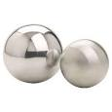
Predict: There are six (6) spherical shaped objects each made of a different material. Predict the densities of each sphere by arranging them in order from 1 least dense to 6 most dense.

Wood _____
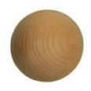
Aluminum _____
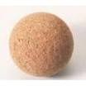
Lead _____
Copper _____
Iron _____
Cork _____

Measure: Density is a measurable physical quality. You can find the density of an object by measuring it's mass and the dividing that number by its volume (density=mass/volume).

Sphere | Mass | Volume | Density
Wood
Aluminum
Lead
Copper
Iron
Cork

Conclusion: Complete the sentences below using the words: float, or sink.

- If an object has a density of less than 1, it will __________________________.

- If an object has a density greater than 1, it will _________________________.

