Directions: cut out the flaps, fold them on the dotted lines and paste them onto the correct organelle.
-----------------------------------------------  This part of the cell is like a library. It contains all of the information for the cell. | ------------------------------------------  This part of the cell is like a power plant. It transfers energy stored in food into ATP which is used for energy in the cell. 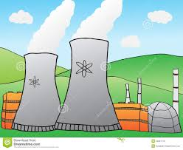 | ----------------------------------------  This part of the cell can take up to 95% of a cell’s volume. It is a place to store waste and other materials. 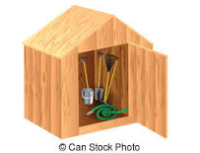
----------------------------------------------  This part of the cell is like a kitchen. It makes energy for the cell.  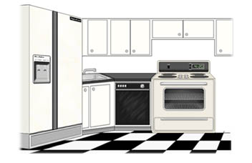 | ------------------------------------------  This part of the cell is like bubble-wrap. It protects cell organelles and holds them in place. | ----------------------------------------  This part of the cell is like a door. It lets things in and out.  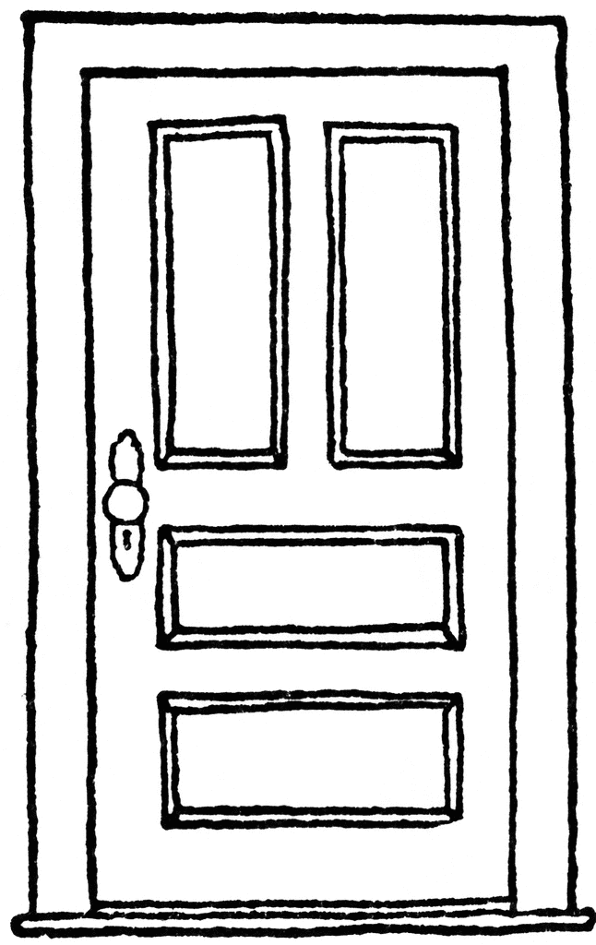
-----------------------------------------------
This part of the cell is like the framing of a house. It provides structure and support.

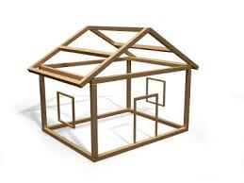

Directions: write a description of each organelle in the appropriate box on the lines. Be sure to describe the organelles function (job) within the cell.
----------------------------------------------  Vacuole  __________________________________________________________________________________________________________________________________________________________ | ------------------------------------------  Chloroplast  ___________________________________________________________________________________________________________________________________________________ | ----------------------------------------  Cytoplasm  ____________________________________________________________________________________________________________________________________________
----------------------------------------------  Nucleus  __________________________________________________________________________________________________________________________________________________________ | ------------------------------------------  Cell Wall  ___________________________________________________________________________________________________________________________________________________ | ----------------------------------------  Cell Membrane  ____________________________________________________________________________________________________________________________________________
----------------------------------------------
Mitochondria

__________________________________________________________________________________________________________________________________________________________

