Name __________________Hr__

Refraction Lab
Light (Direction in a New Medium)
Use the equipment to investigate how a beam of light travels when it encounters a new Medium.

Observe the stirring rod in the WATER at a 45' angle. Record what you see from both perspectives (above the beaker and from the side of the beaker).
Draw a diagram of your results below.
Above the Beaker Side of the Beaker
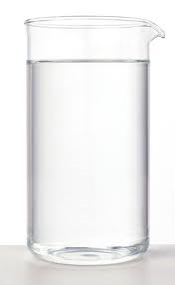
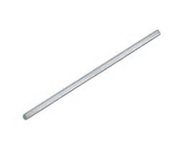

Observe the stirring rod in the OIL at a 45' angle. Record what you see from both perspectives (above the beaker and from the side of the beaker).
Draw a diagram of your results below.
Above the Beaker Side of the Beaker

Observe the stirring rod in the MIXTURE at a 45' angle. Record what you see from both perspectives (above the beaker and from the side of the beaker).
Draw a diagram of your results below.
Above the Beaker Side of the Beaker

Analyze

- What is Refraction?
________________________________________________________________________________________________________________________________

- Based on your observations, what happens to light when it hits a new medium (going from air to water or oil)?
________________________________________________________________________________________________________________________________________________________________________________________________

- Do different mediums make light refractions look different? (Use you observations from the mixture for this question)
________________________________________________________________________________________________________________________________________________________________________________________________

