Name _______________
Hr. ____ Date ________
Slideshow Notes
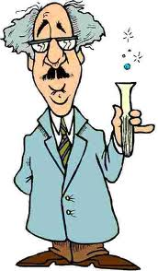
To be completed during slideshow and used as a study guide.

The 7 Steps in Order
1)_______ the problem
2)Gather _________ on the problem
3)Form a ____________
4)Design and perform the ___________
5)Record and analyze the ______
6)Form a ___________
7)Repeat, repeat, repeat
Scientific Method
● Be able to identify the following:
– Problem Statement- a ___________ you would like to solve (includes an independent and dependent variable)
– Hypothesis- an “______,______” statement which tries to predict the results before the experiment is completed
– Conclusion- a statement which declares the __________ of your experiment

Problem Statements, Hypotheses & Conclusions
● Examples:
– Problem Statement: Will a Bounty paper towel absorb more liquid than a Brawny paper towel?
– Hypothesis: If we try to absorb liquids using Bounty and Brawny paper towels then, Bounty will absorb the most.
– Conclusion : The Bounty paper towel absorbed more liquid than the Brawny
paper towel.

Variables and Constants
● Variables are changes in an experiment
– Independent- The thing you _____________.
– Dependent- The thing you ______________.
- Constants (sometimes called controls) are all the things that must remain the _______ in an experiment.

Variable and Titles on Graphs
● The independent variable should be on the ____________ (ie. X-axis)
● The dependent variable should be on the _____________ (ie. Y-axis)
– Don't forget to use the unit (ie. cm, kg, etc.)
● The title should be on the _______ and should be independent variable vs. dependent variable.

Numbering the Graph
● Always try to count by numbers which are easy to count by (examples: 1, 2, 5, 10, 20,25, 50, 100, etc.)
● When you find numbers which work for your set of data, carefully number the lines.
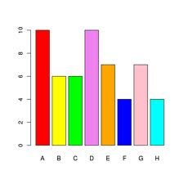
Making the Bars
● Decide how wide your bars should be based on
– The graph paper you are given
– The number of bars you have to graph
● Make your bars the appropriate height
● Label each of your bars

Which Scope?
● A _____________ is used for looking at really small objects.
– A bee's leg
– A blood smear
– A piece of hair
● A _____________ is used for looking at objects which are far away.
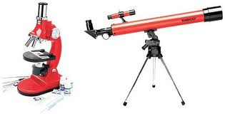
– Planets
– Stars which are far away

