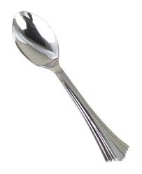
Name ________________
Science Experiment Sheet
Light (Concave/Convex Mirrors)

Draw a diagram of concave. Draw a diagram of convex.

- Look into the spoon from the concave side. Describe what you see.
______________________________________________________________________________________________________________________
- Now, touch your right ear. Describe what you see.
______________________________________________________________________________________________________________________
- Next, touch your finger to the center of the spoon. Was your finger upside down or right side up? Why?
______________________________________________________________________________________________________________________
- Flip the mirror backwards, so that it is convex. Touch your right ear. Describe what you see.
______________________________________________________________________________________________________________________
- Based on your observations, which type of mirror would work best for security? Explain your answer.
______________________________________________________________________________________________________________________
- Which type of mirror would work best to help a man shave, or a lady pluck her eyebrows? Explain your answer.
______________________________________________________________________________________________________________________
- Which type of mirror is in the back of a flashlight, or head light, in order to project more light? _____________________________________

